Eduardo Enrique D. Javier

IT102 7:00Am-10:00Am

**Input:**

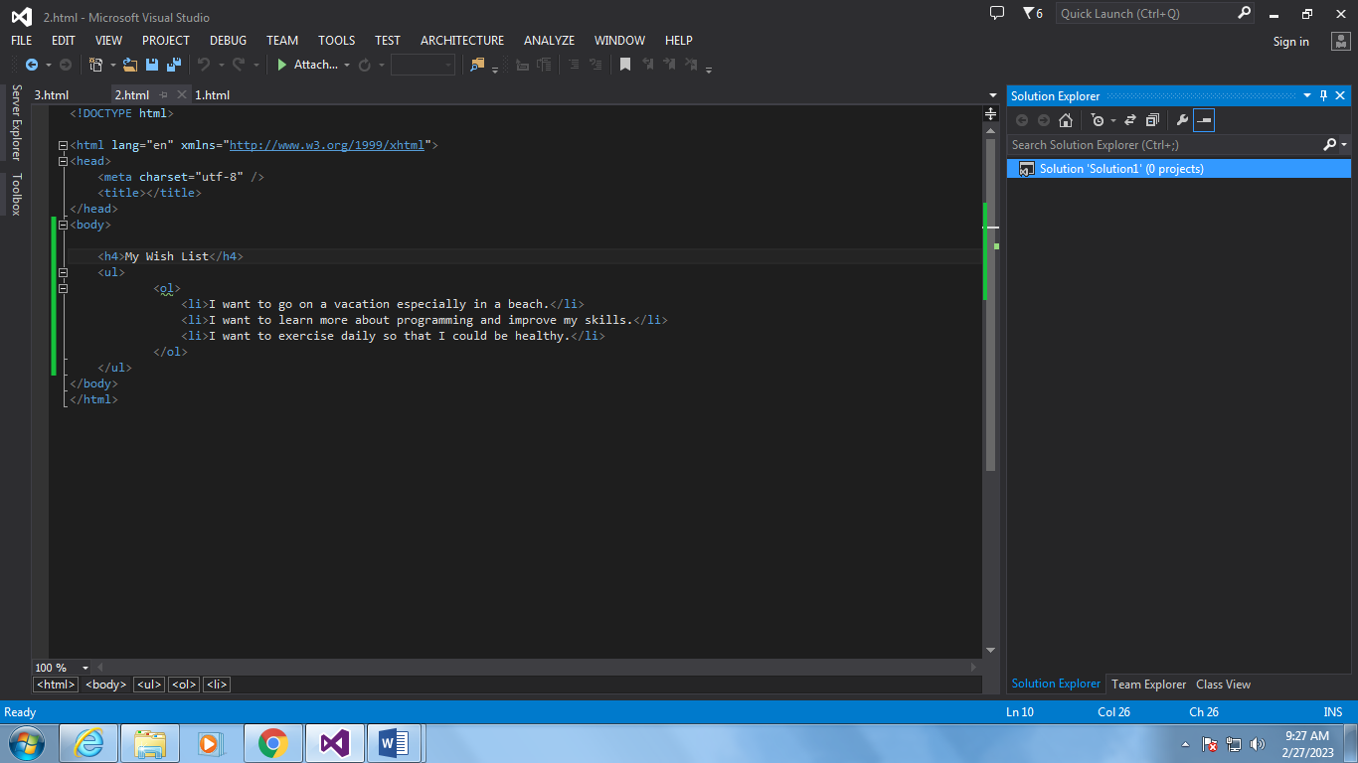

**Output:** 